Deploy a Sample Python Application Using Flask Module

# Case Study: Deploy a Sample Python Application Using Flask Module Python

Python is a popular programming language. It was created by Guido van Rossum, and released in 1991. It is used for:

* web development (server-side),
* software development,
* mathematics,
* system scripting.

# Syntax:

Python syntax can be executed by writing directly in the Command Line: Print(‘hello world’)

# Flask Module:

It is the latest and comprehensive guide designed for beginners and professionals to learn **Python Web Framework Flaskone**. It is one of the most popular Python-based web frameworks.

Flask, a Python web application framework, was created by Armin Ronacher. Known for its lightweight and efficient nature, Flask is designed for quick starts and accommodates complex applications. It is based on the Werkzeug WSGI toolkit and Jinja2 template engine.

In this application we have to use – Launch an ec2 instance

Install python3 and pip Install flask module

In app.py we have to import the code .

We have to Launch an ec2 instance in Ubuntu or Linux server.

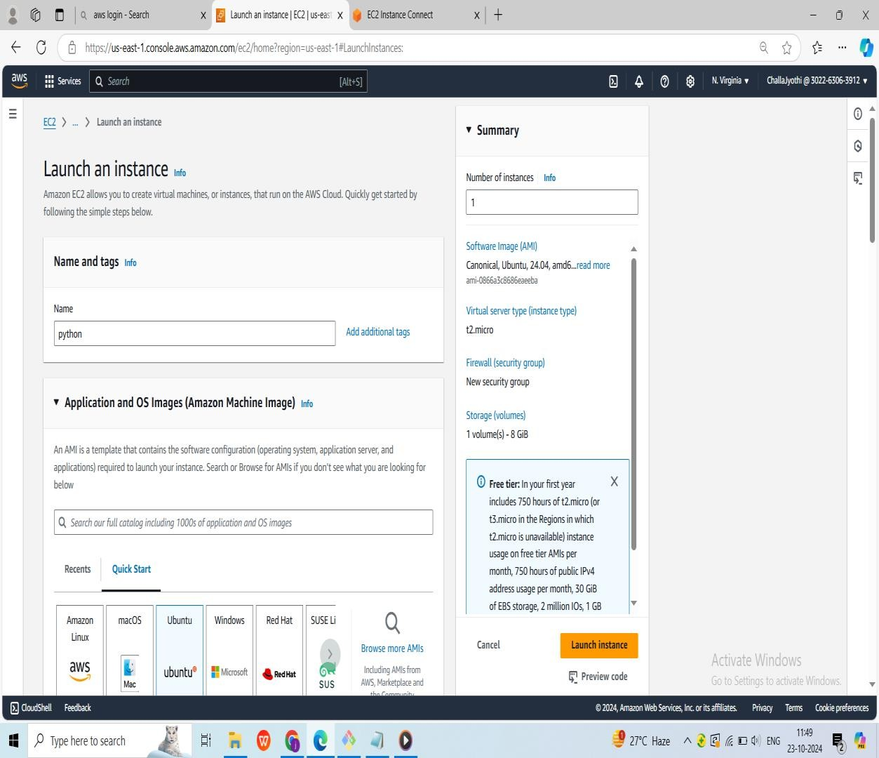

We have to create key pair and edit the security port as 5001

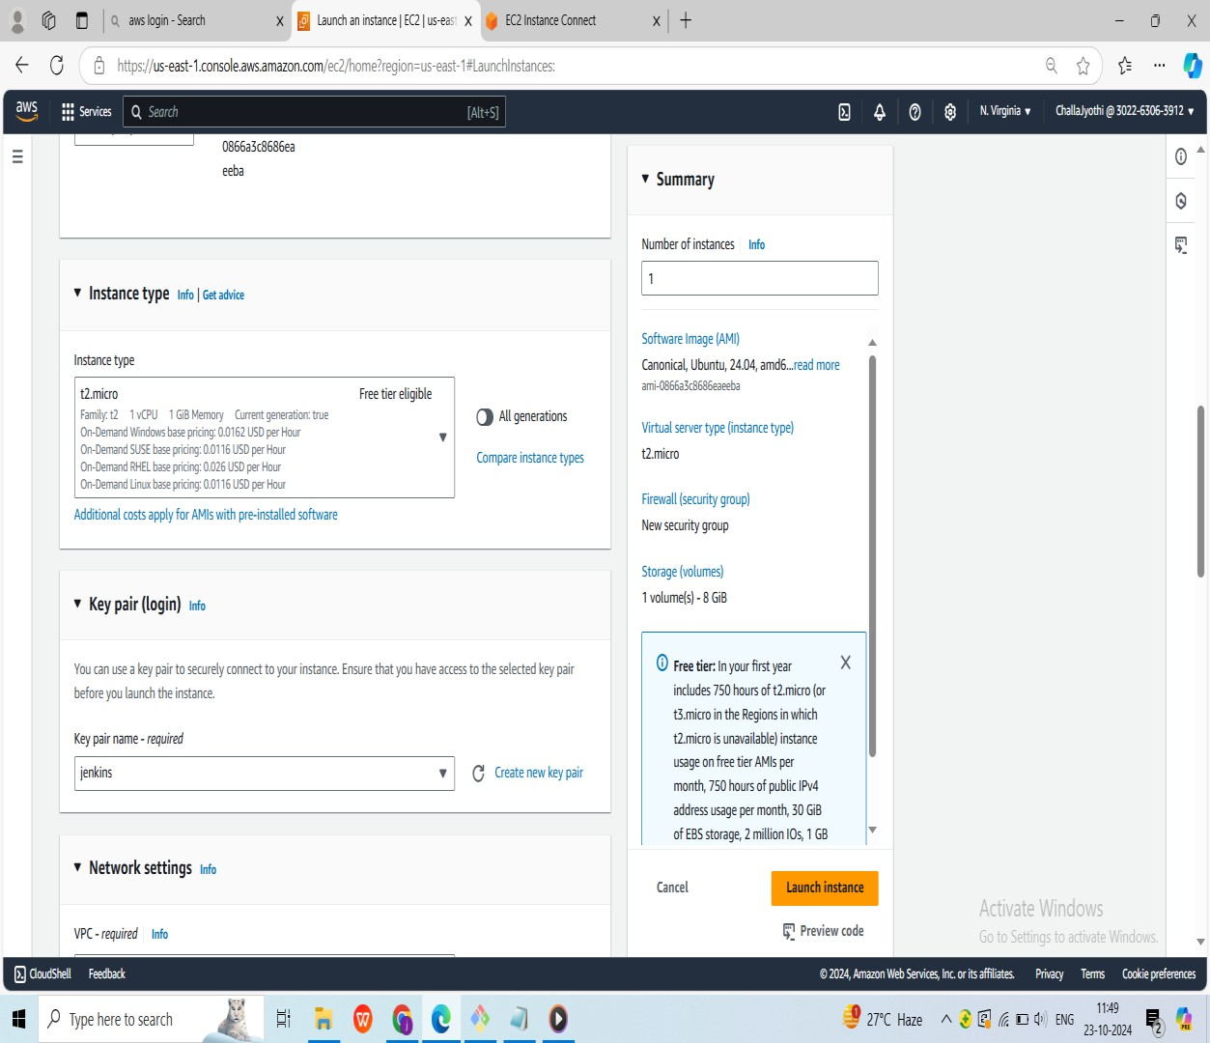

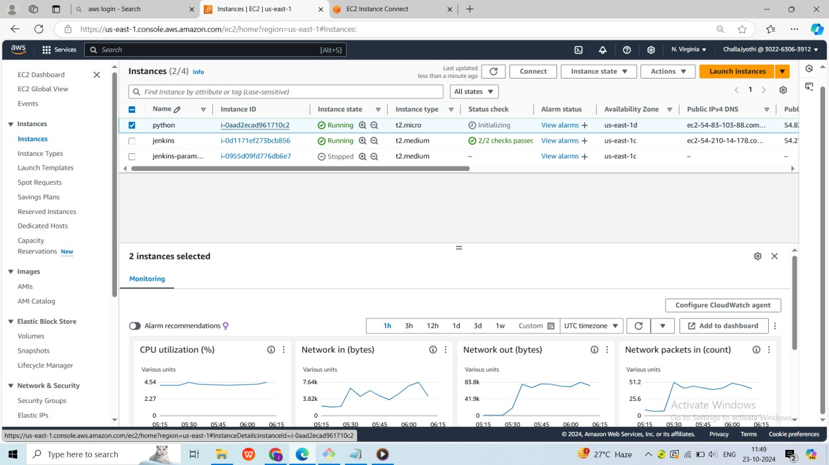

Once, the instance is launced we have to connect to server

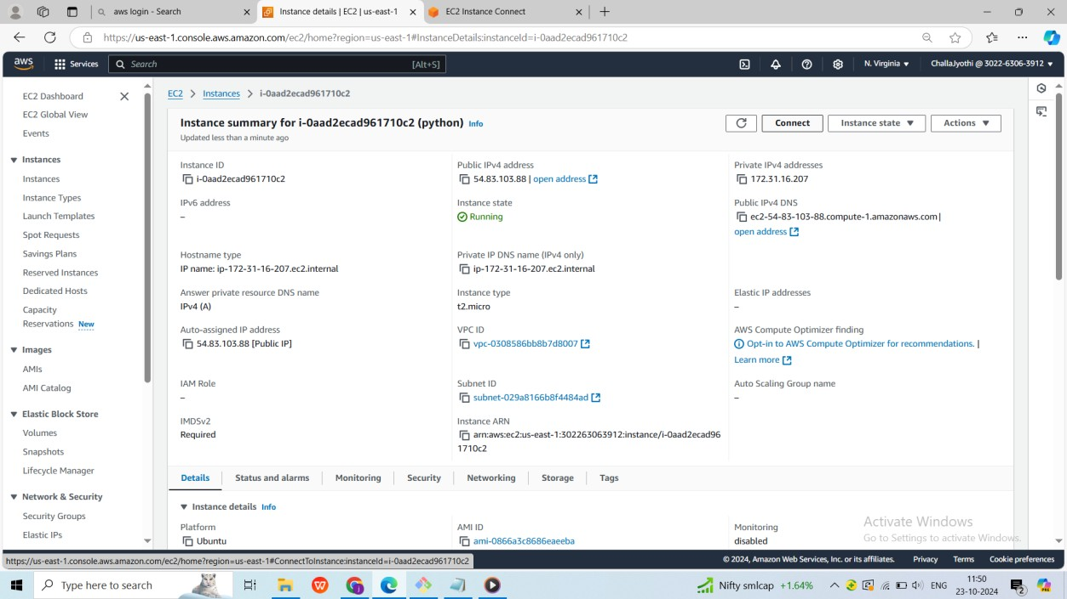

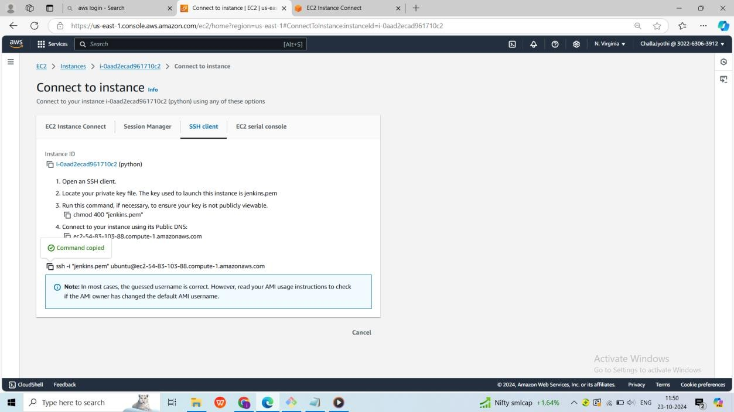

Connecting to the server

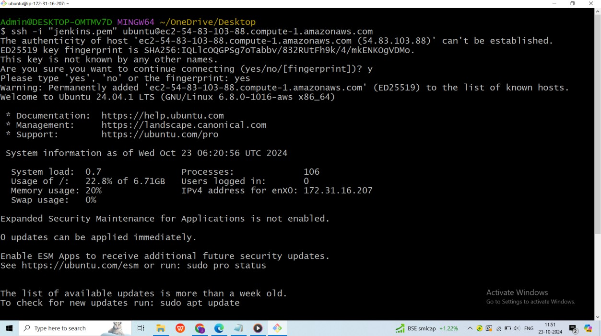

To switch normal user to root user we use **sudo –i**

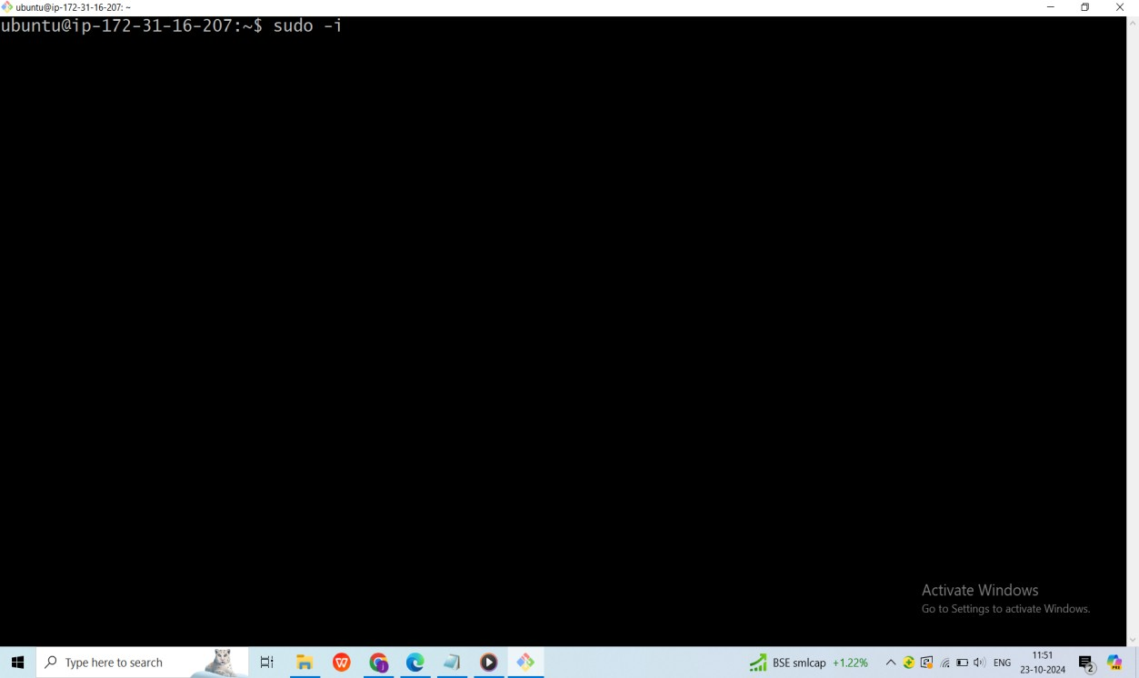

We have to install python3 version(**apt install python3**) ,if it already exist we have to check version **(python3 –version)**

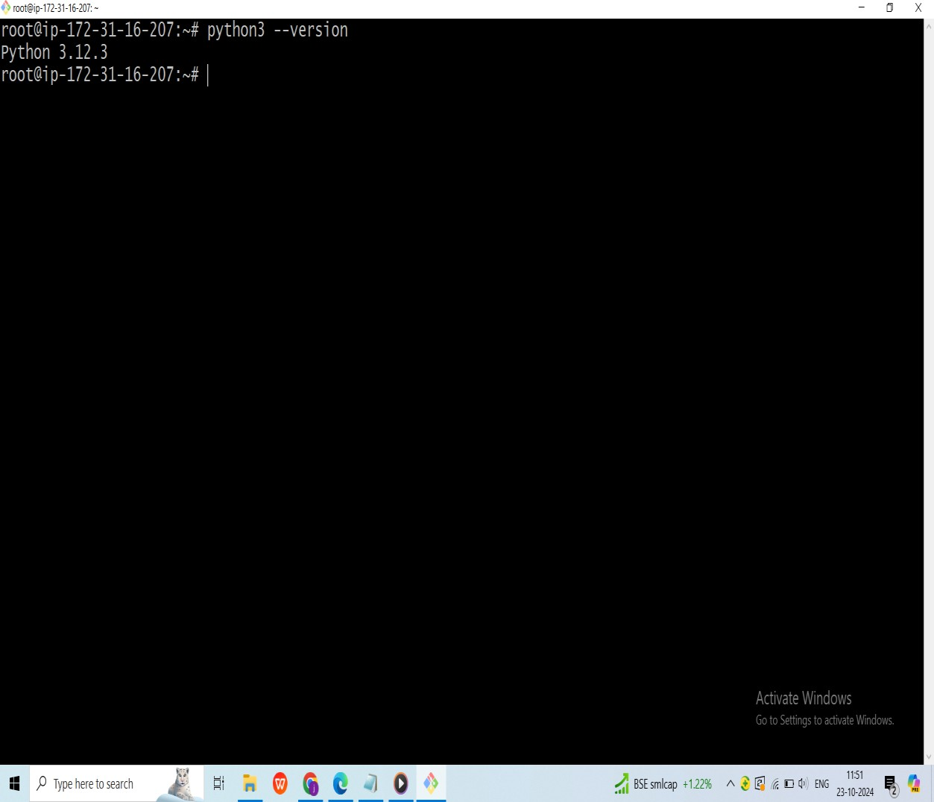

We have to update the server **(apt update –y)**

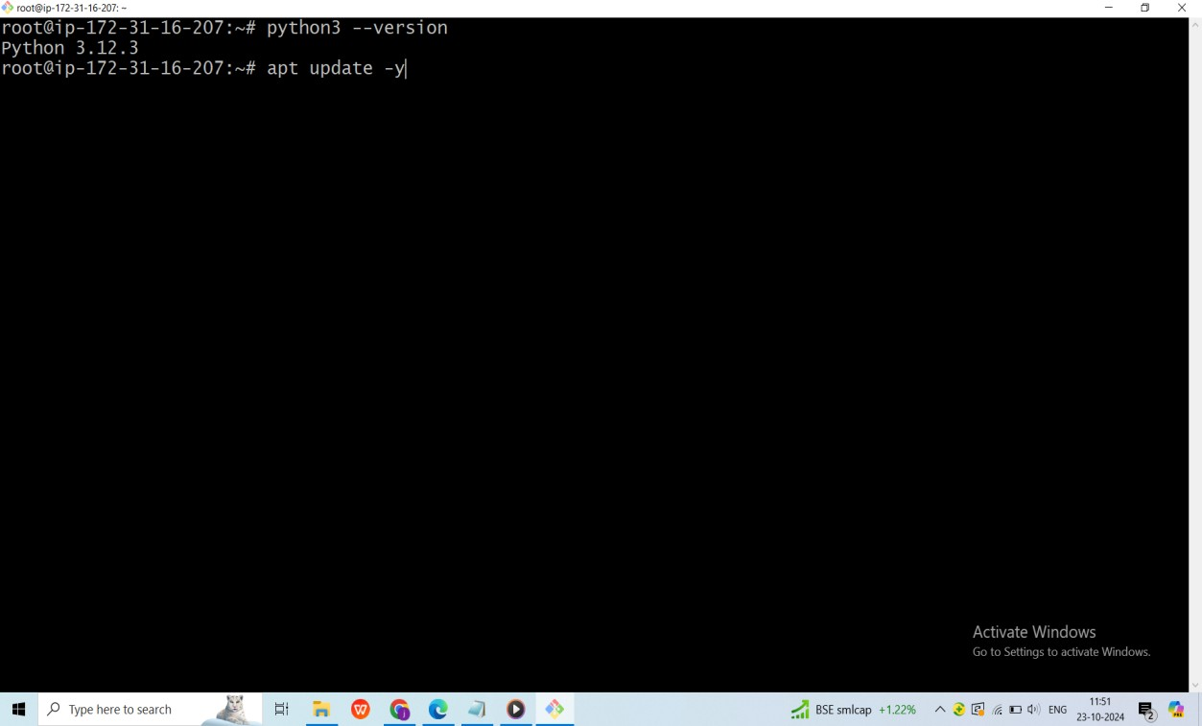

After updating the server we have to install the pip **(apt install python3-pip)**

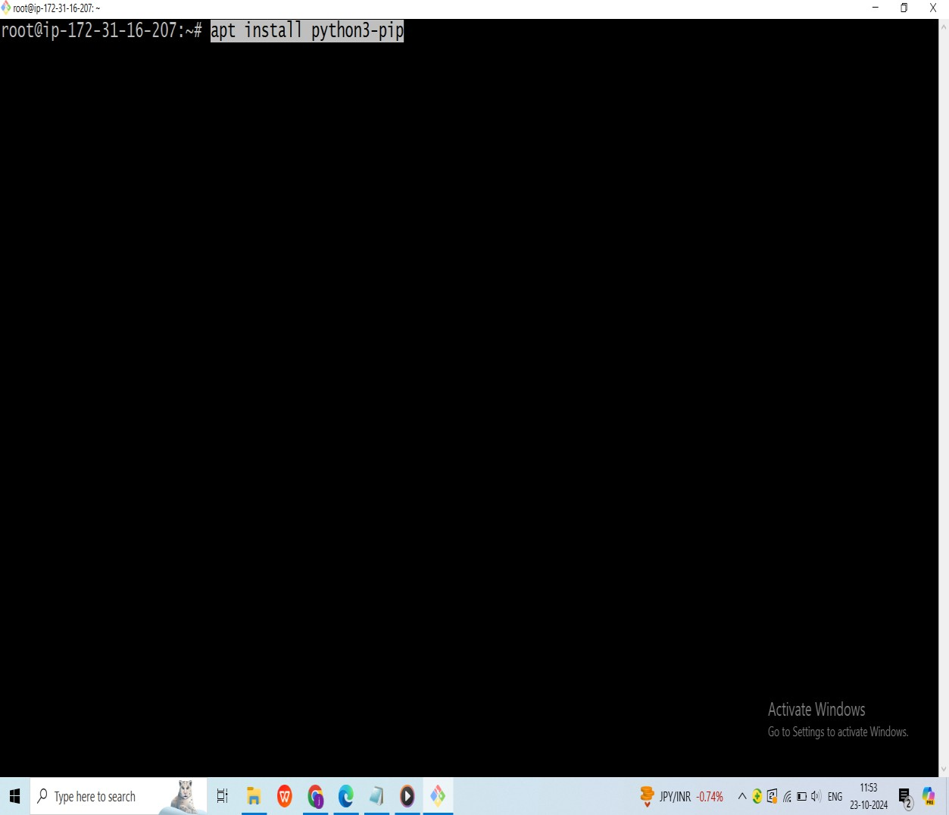

After installing the pip we have to check the version of pip **(pip3 –version)**

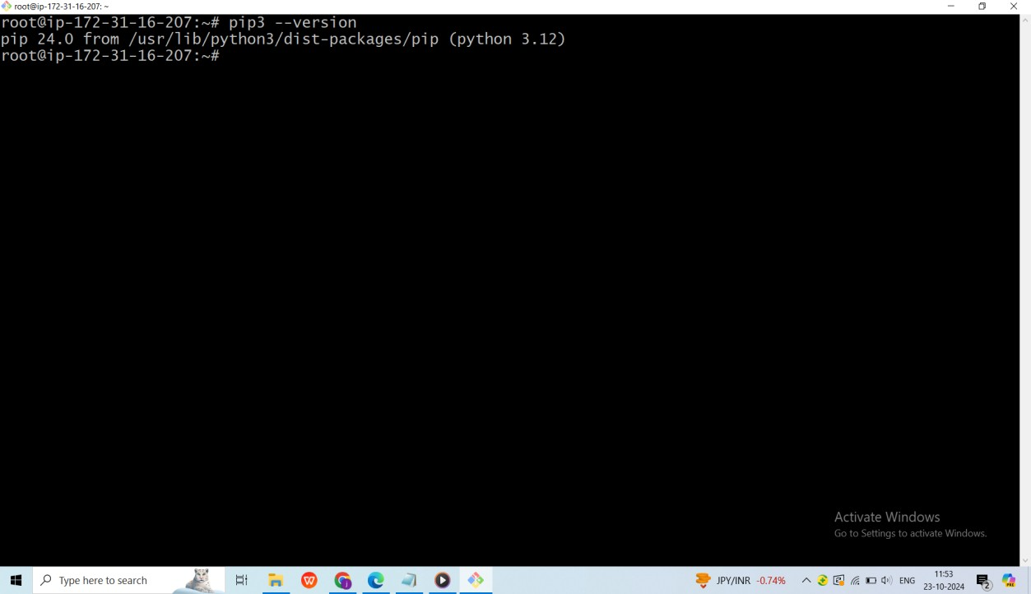

Let us install python3-venv by using the command **(apt install python3-venv python3-pip)**

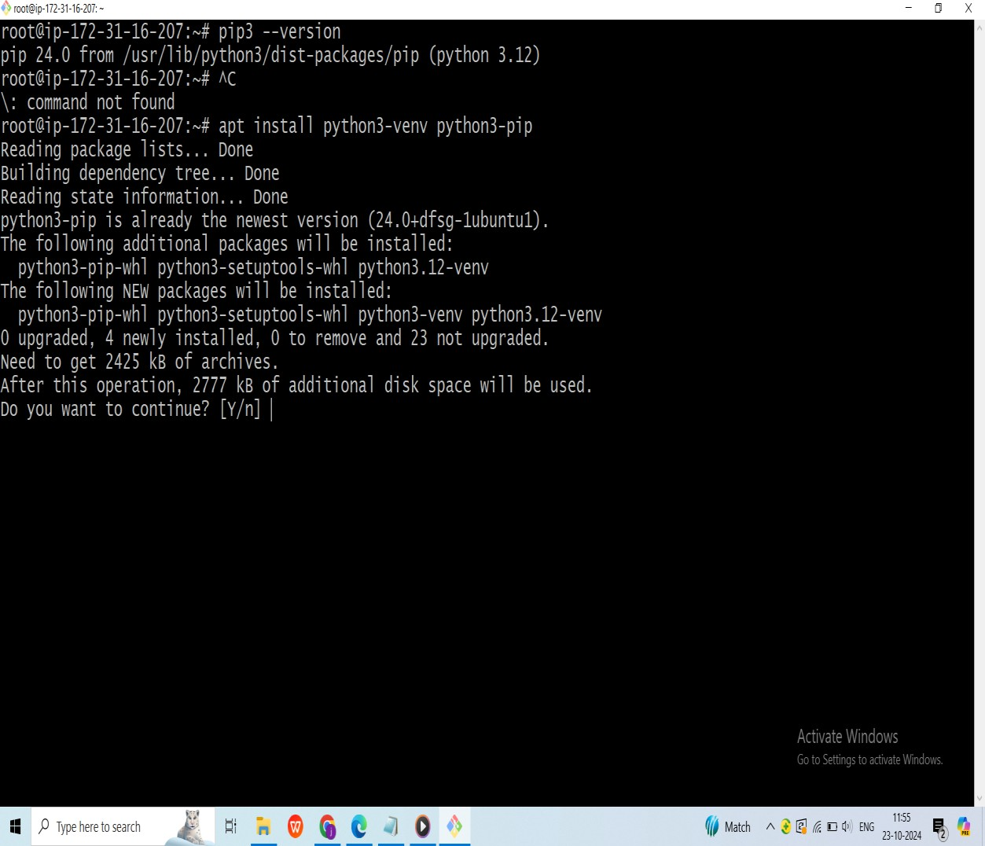

You can install Flask globally with the command pip3 install flask, but it’s recommended to create a virtual environment and install the Flask application there. Let’s create a new user and install the Flask application in a new virtual environment: **(adduser python)**

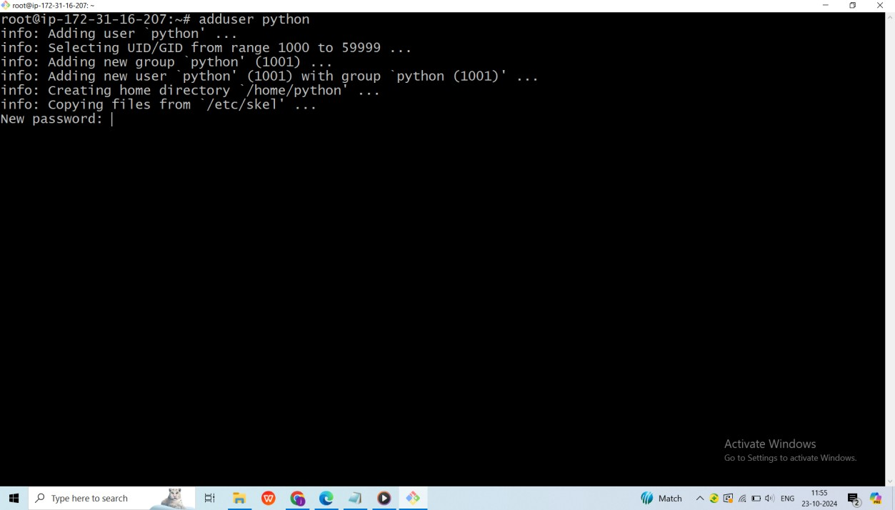

Now, you can log in as the user john with the above command. **(su – Python)**

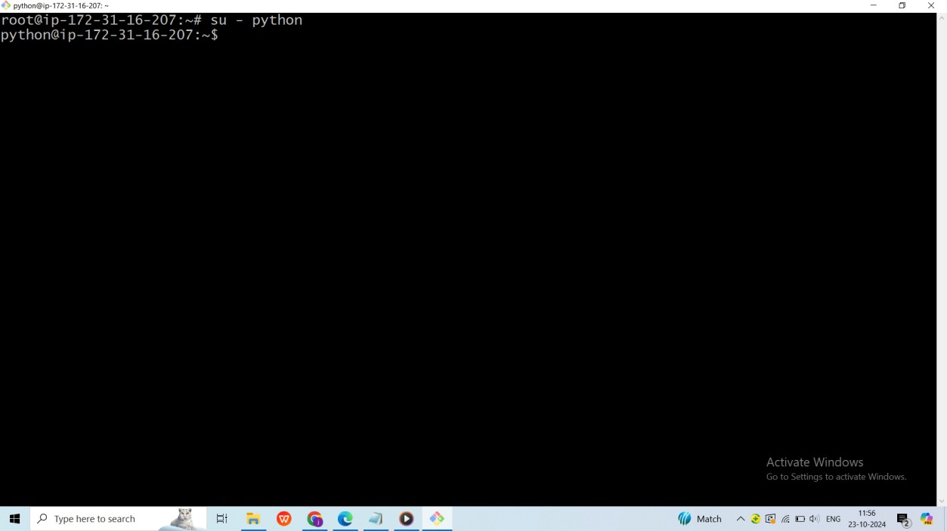

After logging in, create the directories flaskapp/templates **(mkdir –p flaskapp/templates)**

Enter the directory called **flaskapp (cd flaskapp)**– you can now go ahead and create the virtual environment. **(python3 –m venv virtuaenv)**

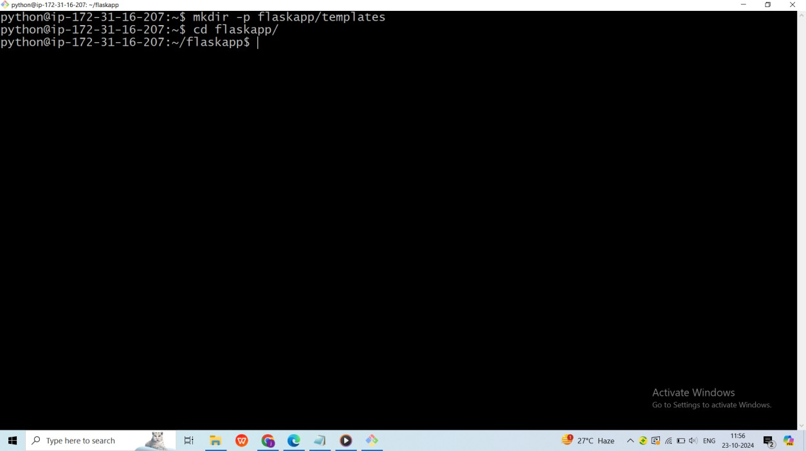

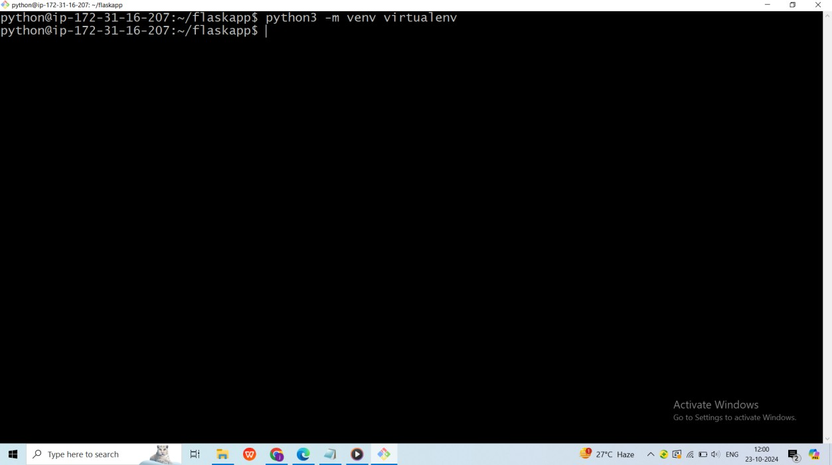

Now enter the virtual environment with: **source virtualenv/bin/activate**

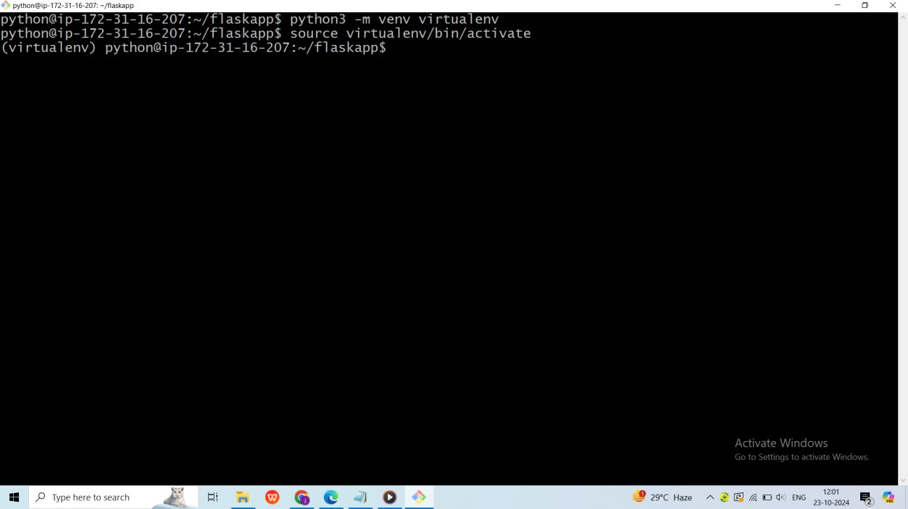

You have now activated the virtual environment, where we can start our installation. Let’s install Flask and Gunicorn: **(pip3 install flask gunicorn)**

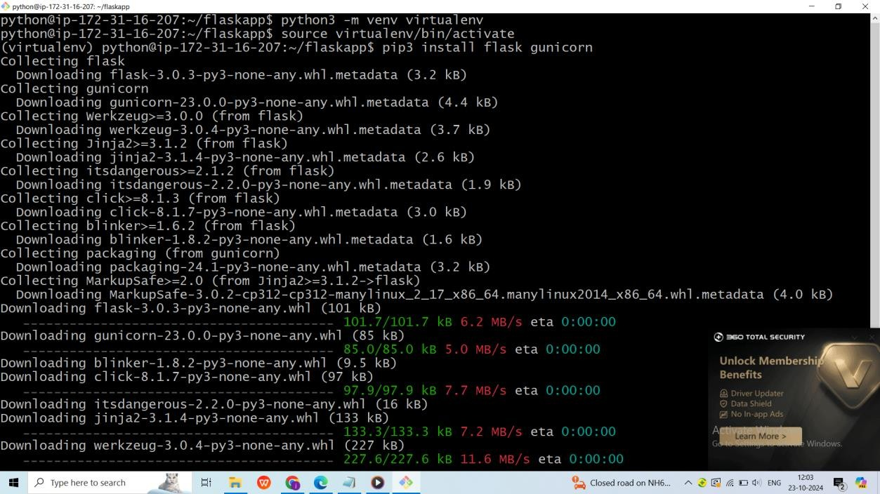

Once Flask is installed, you can run a simple application to test if everything is working as expected. Make sure you are logged in as the user “john”. Create an **app.py** file using your preferred text editor: **vi app.py**

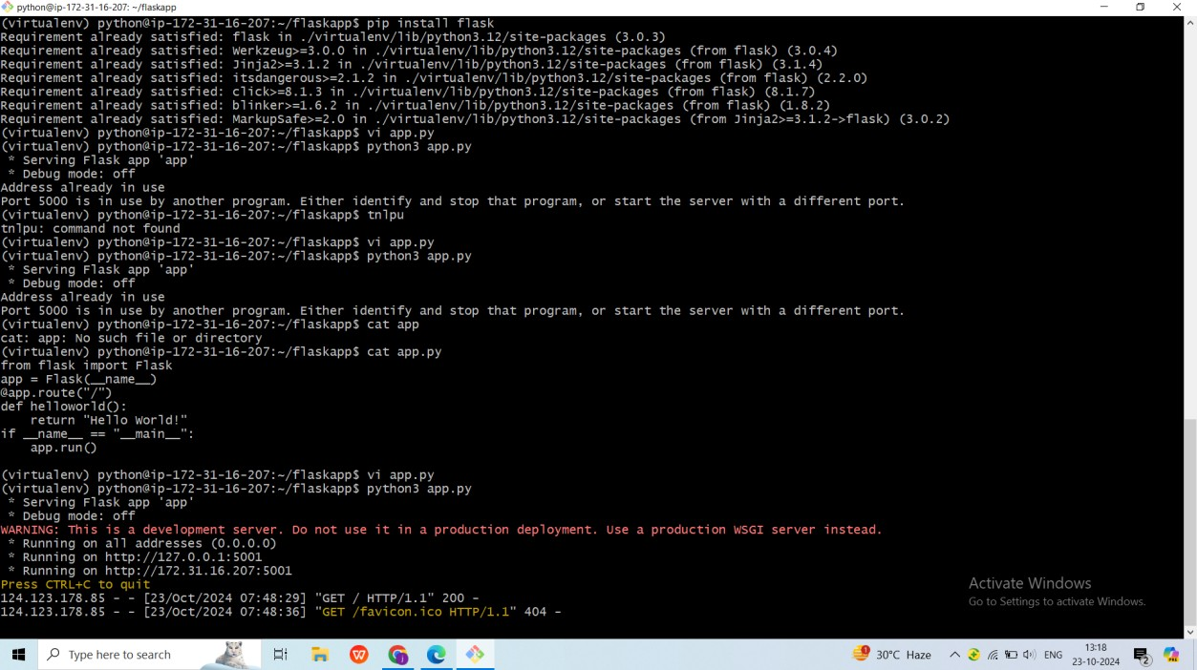

Add the following code to the file:

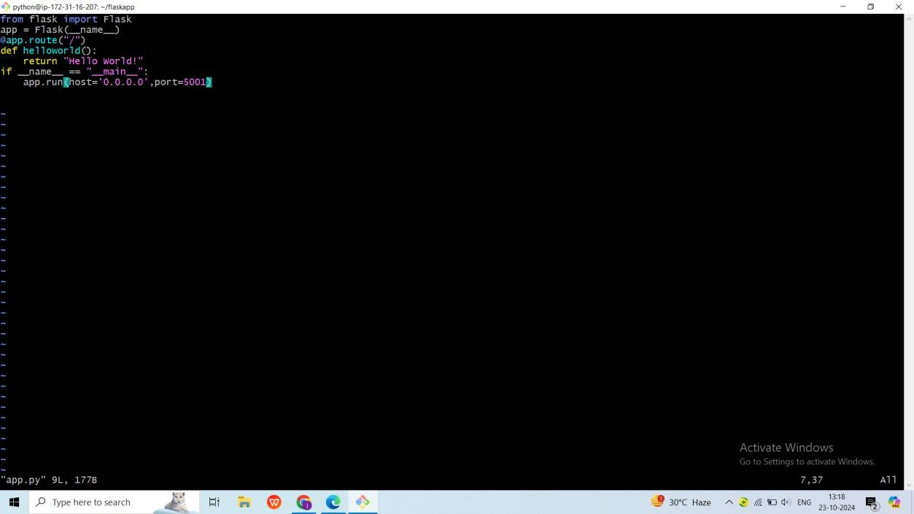

To run the app.py we use **python3 app.py**

Once the code is successful we have to copy the public Ip address and paste in any browser

The final output is:

